CHAPTER 3: Cells
Worksheet 3.8

Looking back
Student: Class:

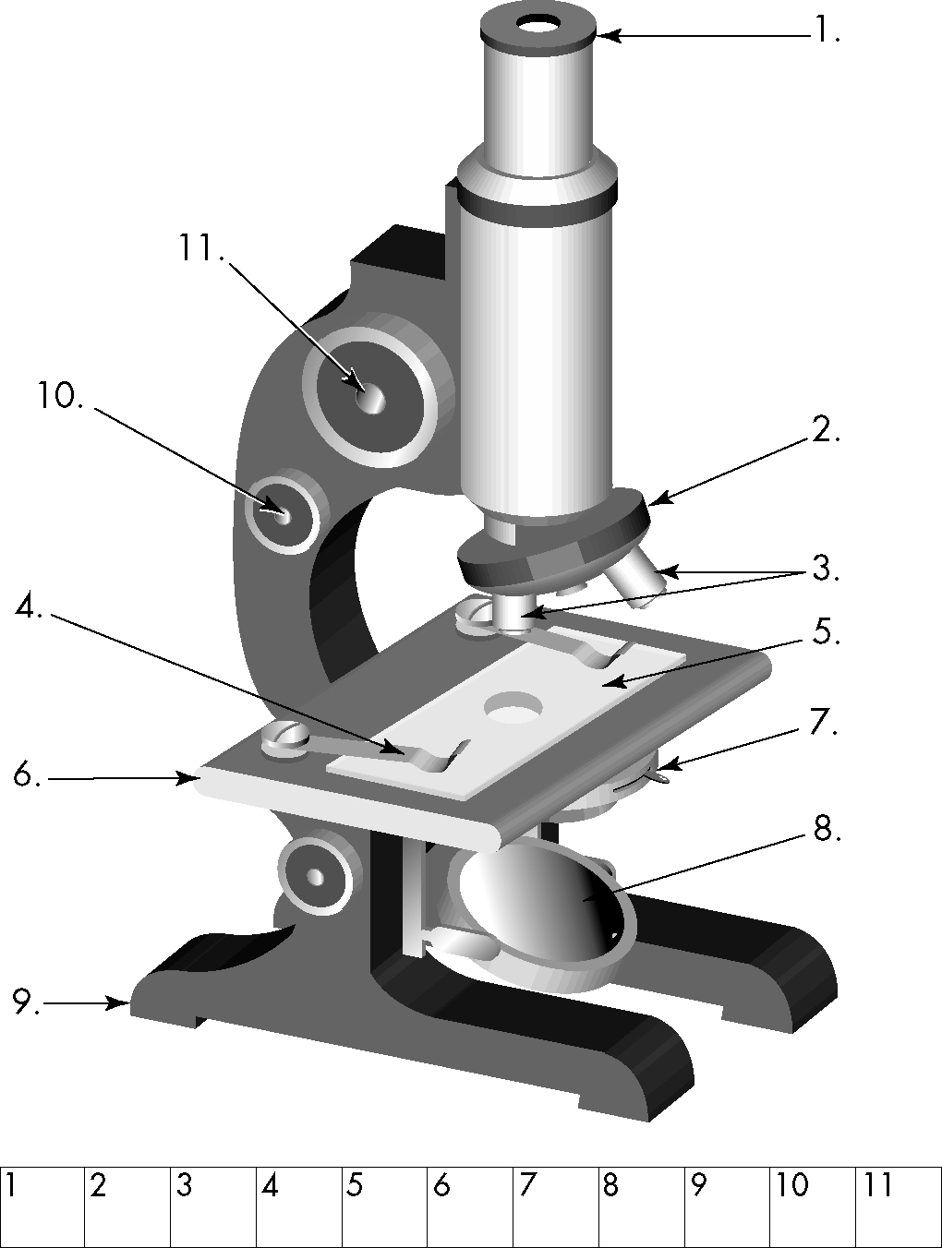
1. Complete the table below:
Cell feature | Plant cells | Animal cells
Cell wall |  | ❒
Cytoplasm
Cell membrane
Chloroplast
Nucleus
Large vacuole
2. What’s green and eats porridge? Identify the parts of the microscope on the right and use the code below to find out the answer to this riddle.
Code:
O = revolving nose piece; U = objective lenses;
S = coarse focus knob; K = fine focus knob;
D = microscope slide; L = stage slide clip; C = base; O = mirror; L = iris adjustment; I = stage;
M = eyepiece lens
3. Unscramble the words using the clues provided.
(a) Control centre of the cell SEUNCLU
(b) Surrounds the cell ERAMMBNE
(c) Contains cell sap OCVAUEL
(d) Part of the cell between the cell membrane and the nucleus CATOPLMYS
(e) Building blocks of all living things LELSC
a
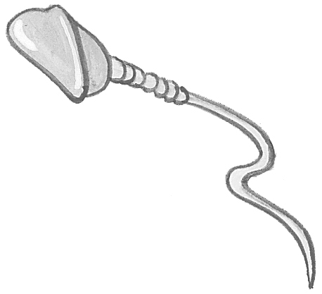
(f) Living things ASMOGNIRS
4. Match the following cell names to the diagrams on the right.
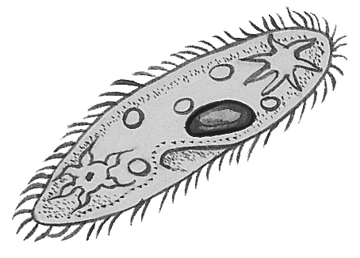
.................... Euglena
d
b
c
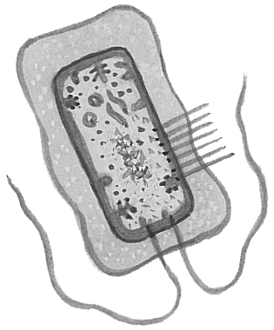
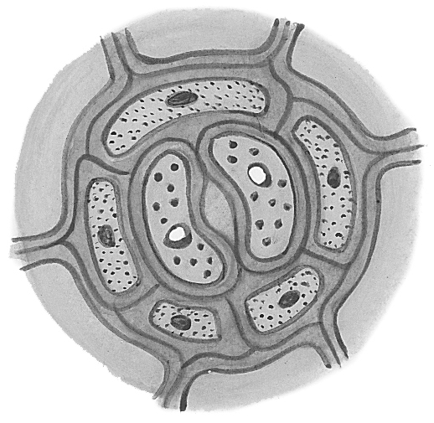
.................... Paramecium
.................... onion epidermal cell
.................... nerve cell
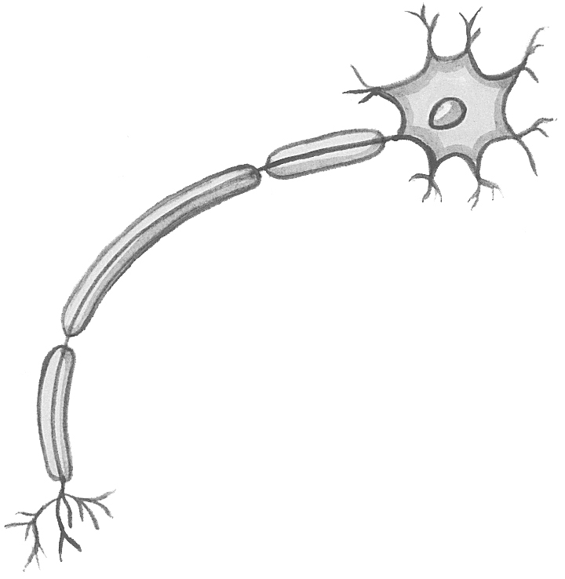
.................... sperm cell
e
.................... guard cells
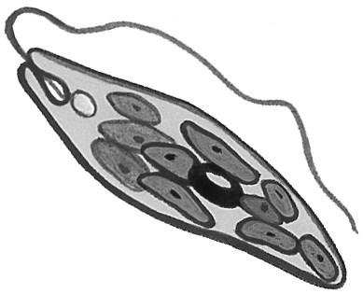
.................... root hair cell
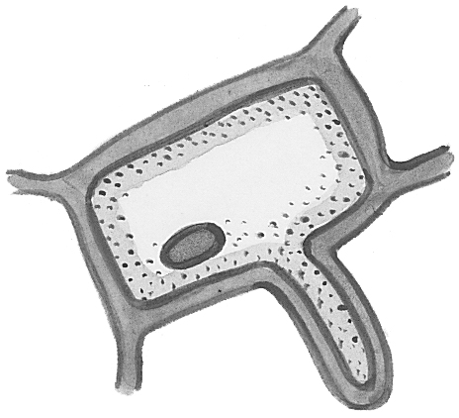
.................... bacterium
h
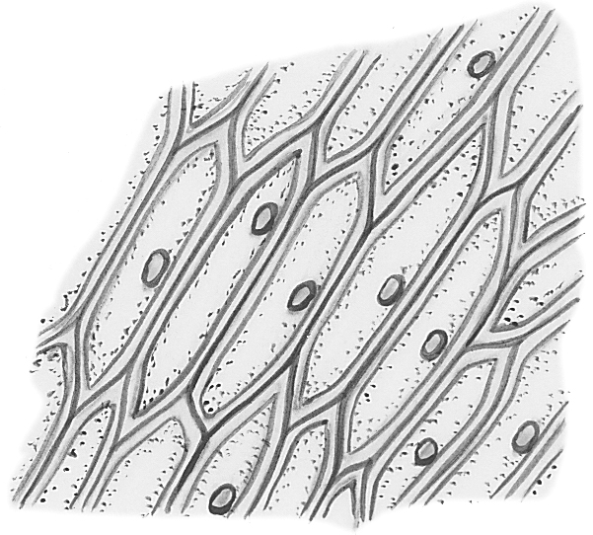
g
f

